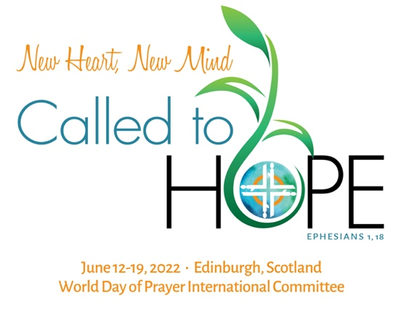

Issue: April 2021

WDP Celebrations / WDP International Committee Meeting

Dear sister,
What a great celebration we had with the Ni-Vanuatu sisters on the World Day of Prayer!
Each one of us, from our corner of the world, proclaimed out loud that we 'Build on a Strong Foundation.' On the first Friday of March, many WDP committees and churches prepared a celebration that could be experienced online, while others organized in-person services under the restricted health guidelines. Like a balm of hope in a world tired of loneliness and losses, the celebrations were filled with enthusiasm and creativity, resilience and dedication.
There was so much joy in connecting with familiar friends or new friends from another city or country during the celebrations. New partnerships were created with young people and local churches who provided the technological assistance needed for WDP worship services online. There were new opportunities created as people unfamiliar with WDP attended the services or watched a video. The movement has learned how to use the new technologies of communication to organize their meetings, plan activities, and to hold the celebrations. We thank God for giving us the tools to come together as #WDPUnitedInPrayer!
You may watch a WDP worship service video by visiting the WDPIC YouTube channel playlist. We also want to remind you to email us the Annual Report of your National/Regional Committee. Your country's experience will be published in the 2021 WDP Journal. Click here to download the Annual Report Form.
Looking forward to the 2022 program, we are connecting two special moments for the movement. Firstly, the worship service program prepared by WDP England, Wales and Northern Ireland with the theme 'I Know the Plans I have for You' (Jeremiah 29:1-14) will be celebrated on the first Friday in March. The materials are ready and have been distributed to all WDP National Committees. Please, contact WDPIC if your National/Regional Committee does not have the worship service materials.
Secondly, the WDP International Committee Meeting is to be hosted by WDP Scotland, under the theme 'New Heart, New Mind. Called to Hope' (Ephesians 1,18) in June. There is a common thread within these two themes. Both Bible texts speak about hope during troubled times, trust to overcome uncertainties, and openness to accept the new.
In March of 2020, we were caught by surprise with the World Health Organization's declaration of the COVID-19 pandemic while we were praying with our Zimbabwe sisters, and in 2021 we adapted to our new situation and prepared alternatives to in-person services to pray with our Vanuatu' sisters. We want to bring this spirit of preparedness and resourcefulness to the International Meeting in 2022.
Therefore, considering the current COVID-19 pandemic across the world, the uncertainties of 2022, the new complexities and requirements for international travels, the wellbeing of WDP leadership, the economic impact of the crisis, and financial responsibility with the future of WDPIC and WDP National/Regional Committees, the WDPIC Executive Committee has decided to hold the International Meeting using an online format in 2022 in lieu of an in-person gathering.
This means that the International Meeting will be held with delegates and guests around the world, regardless of their location. We will use video, audio, and text to connect and collaborate via an internet connection. We will build on the technology we already use like emails, mobile chat (WhatsApp, etc.) and web conferencing (Zoom, etc.) to accomplish the purpose of the International Meeting (WDPIC Constitution). We will share, decide, vote, network, listen, talk, report, learn, sing, pray, plan and more without being physically together. It will be a unique experience full of blessings.
From May to November of 2020, WDPIC sent to the National/Regional Committees Newsletters with the information about the International Meeting and the ways that the Committee can participate. From May to July 2021, we are expecting to receive the response forms from each National/Regional Committee. Visit the WDPIC website to download the forms (English, French, Spanish). Here are the deadlines for the committee's responses:
- May 3, 2021 - Delegate registration
- June 1, 2021 - Nominations for Chairperson and Regional Representatives
- July 1, 2021 - Nominations for themes and writer countries for WDP worship service
We ask the National Committees and the delegates to continue reserving in your calendar the week of June 12-19, 2022 for the International Meeting while we adjust the program and procedures to an online format. We count on the participation and support of your National/Regional Committee to sustain in prayer the international sisterhood of WDP.
We are greatly thankful to the WDP Scotland committee for all that they have already done to welcome us in person in Edinburg, and their understanding of the implications of the global situation on the original plan. We will continue our conversation with them on alternative ways to host the International Meeting.
The 2022 WDP themes set the tone for an action-oriented and future-forwarding meeting. Thus, we hold onto our strong foundation trusting that God's plan is to call us to live and act in hope.
Please, click here to send us your questions, comments, and suggestions about the virtual WDP International Committee Meeting in 2022.
Rosângela Oliveira
Executive Director, WDPIC

Share this newsletter with your WDP committee!

